

Internet Programming

TP12



VueJs , NodeJs

LECTURER: HOK TIN

STUDENT: HENG CHHAYHONG

ID: E20190263

Gitlab: https://github.com/HengChhayhong275/TP-IP-TP12

Exercise1: ExpressJS

* Create APIs for Product Price
  + CRUD APIs for price
    - Create price

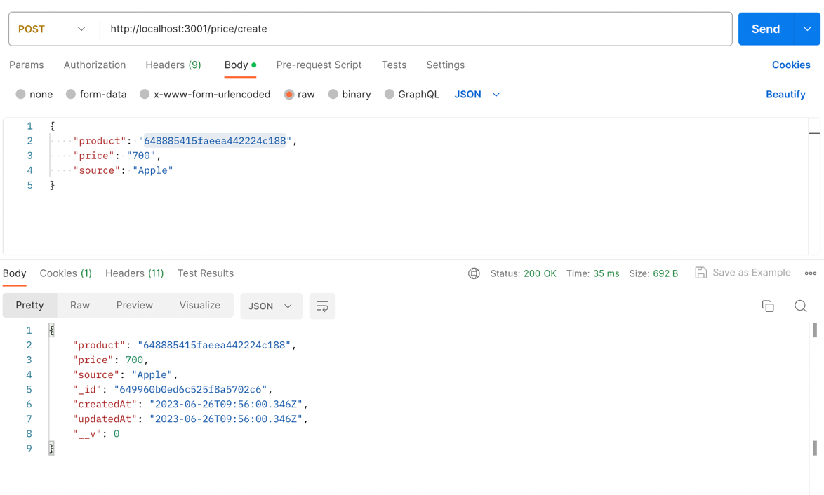

* + - Get all Price

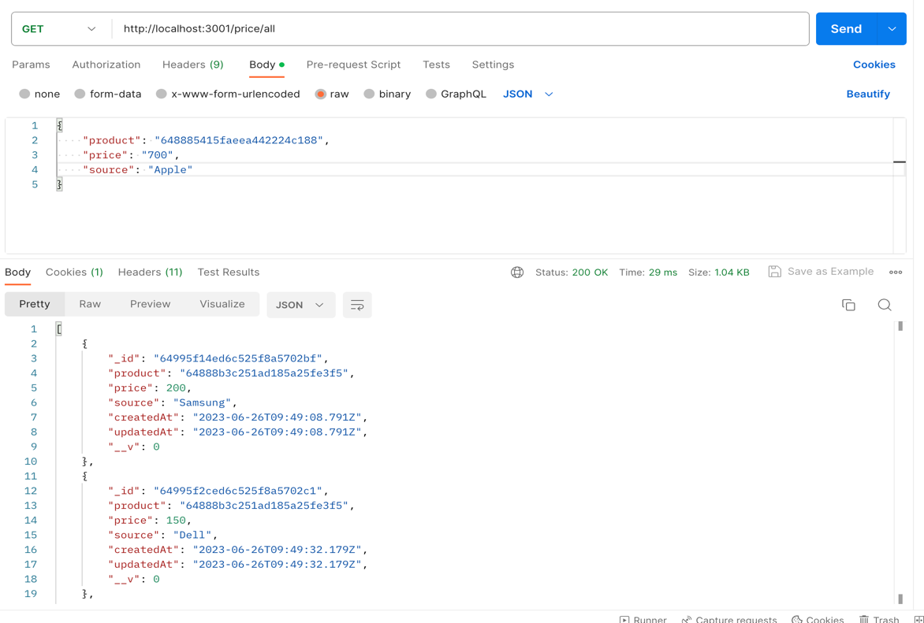

* + - Update Price
      * Before update

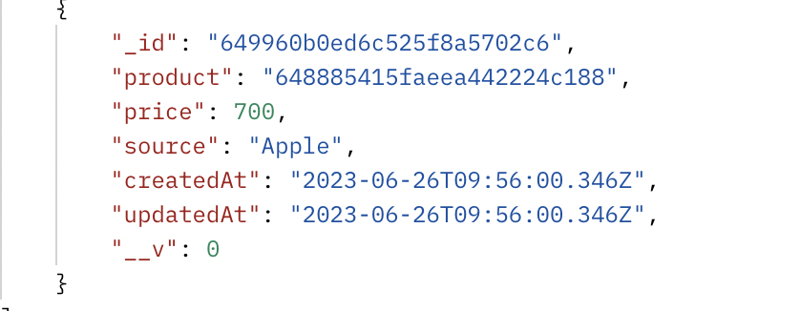

* After update

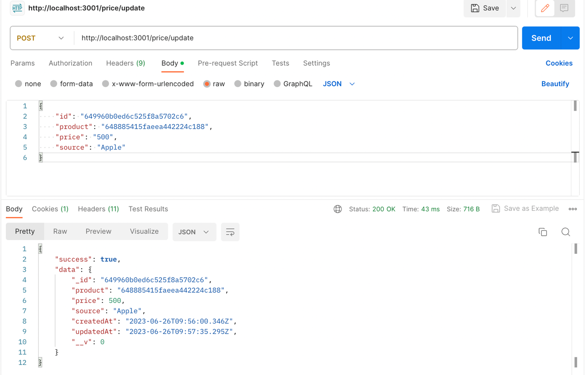

* + - Delete Price

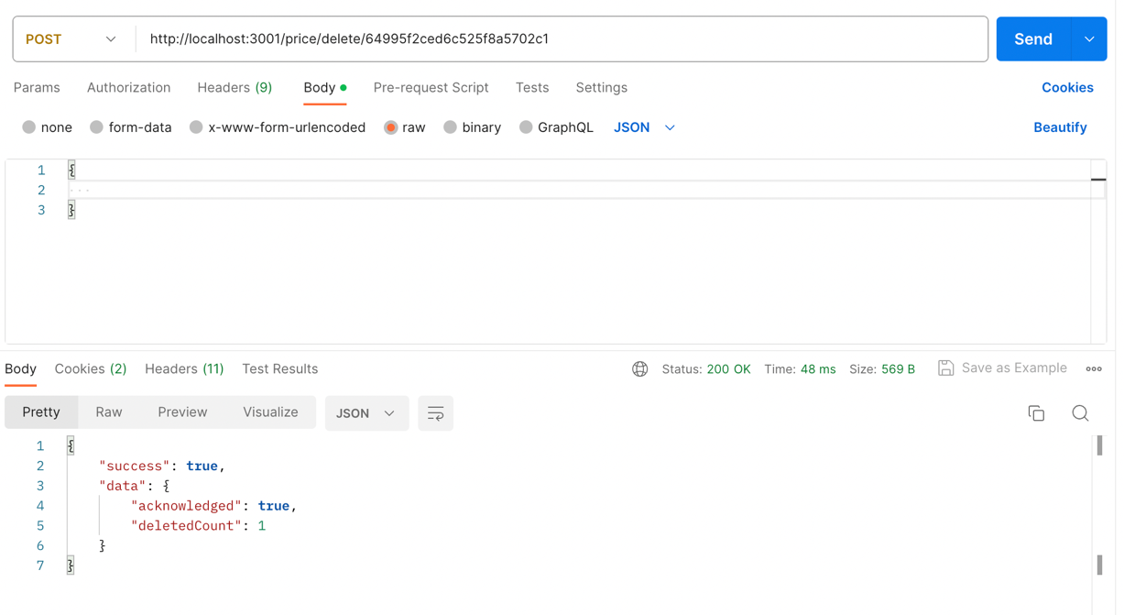

Exercise2: VueJs

* Design basic admin dashboard to manage a dynamic website
  + Login page

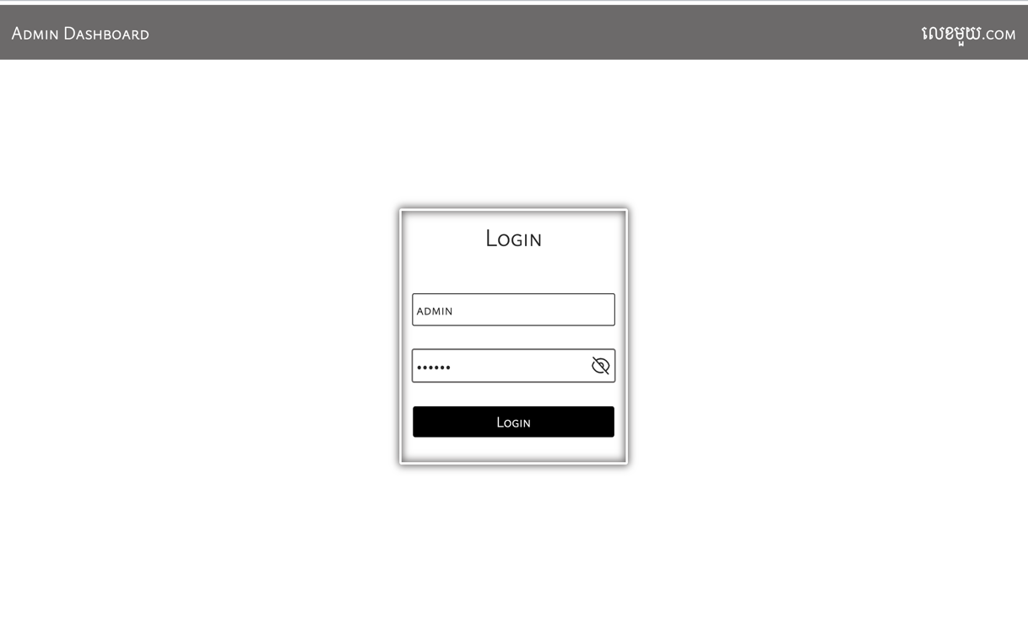

* Management
  + Category

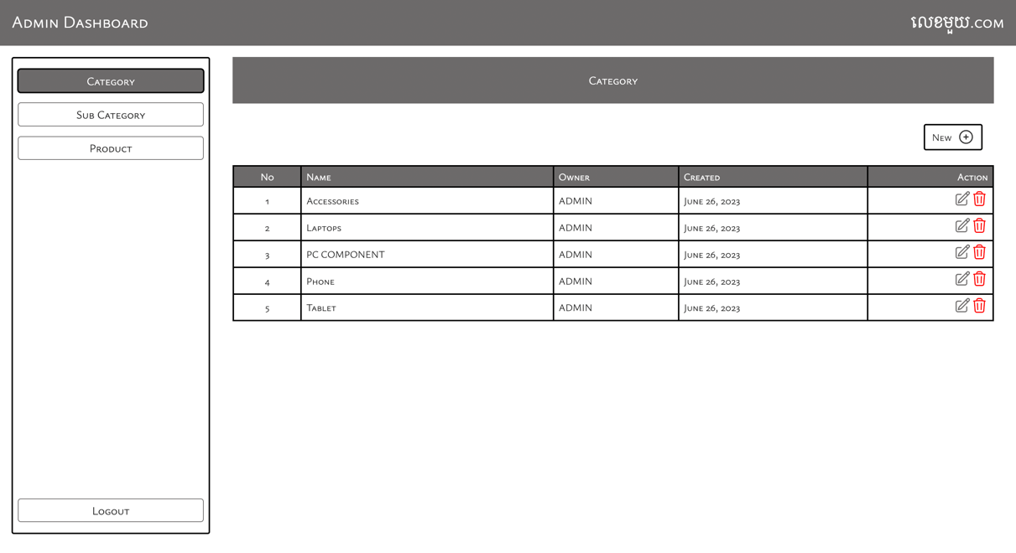

* Sub-Category

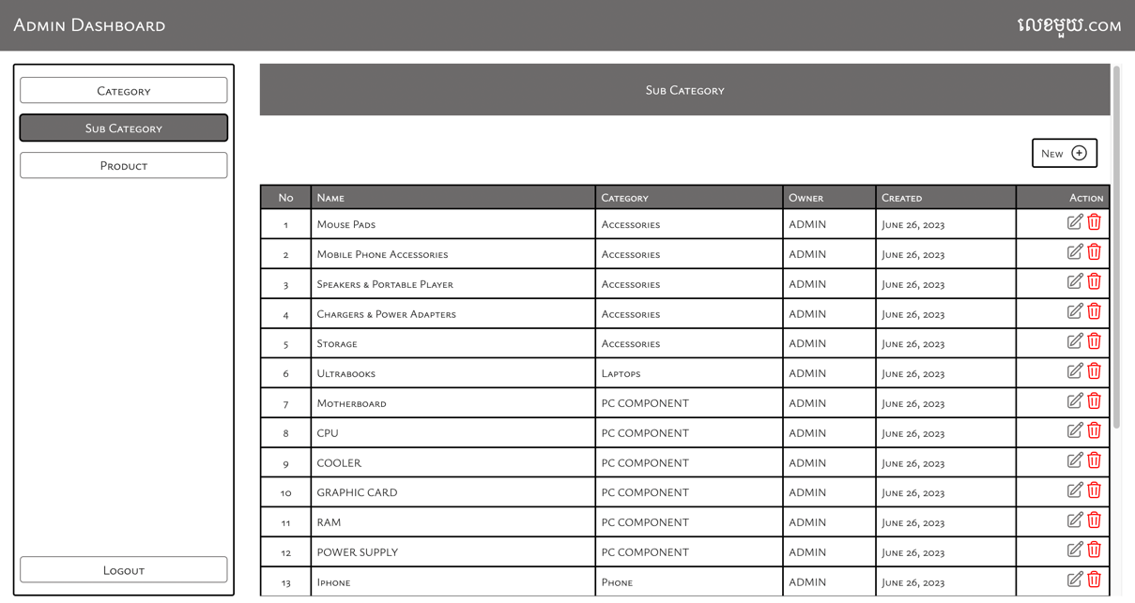

* Product

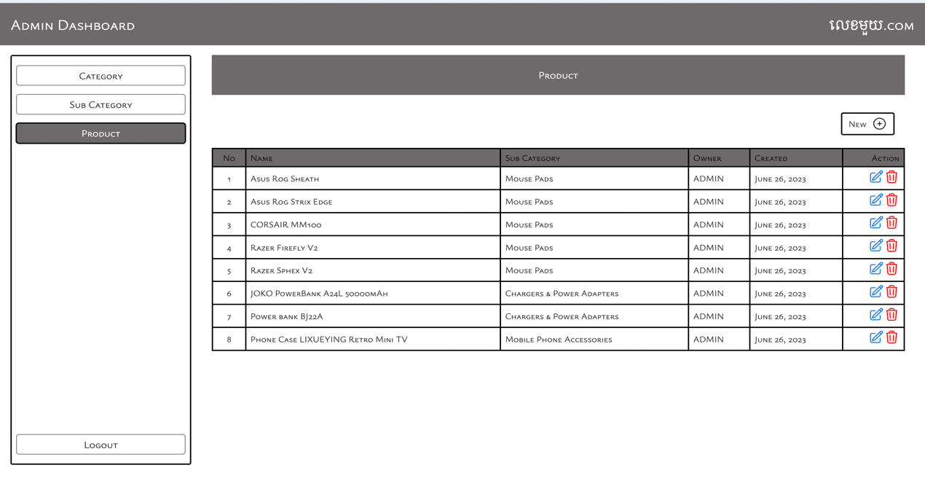

* Creation
  + Category

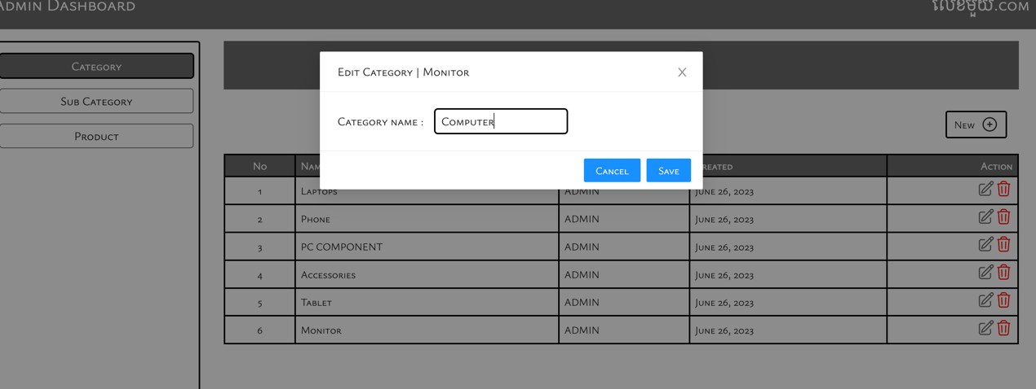

* + Sub-Category

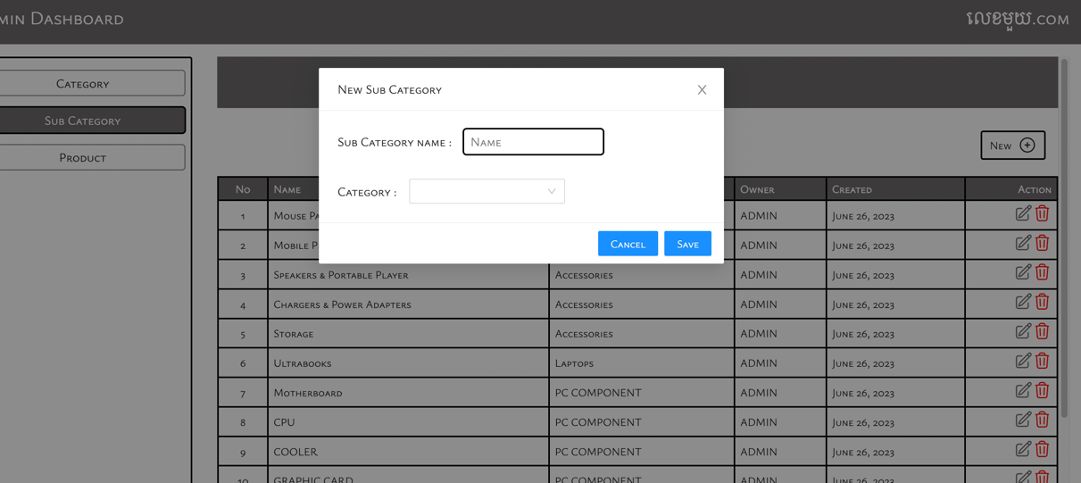

* Product: Not working
* Update
  + Category

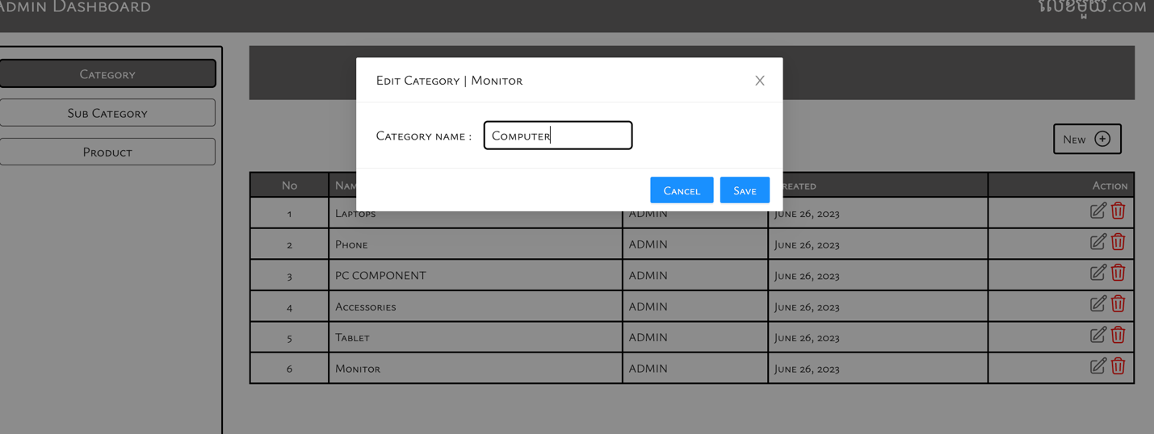

* + Sub-Category

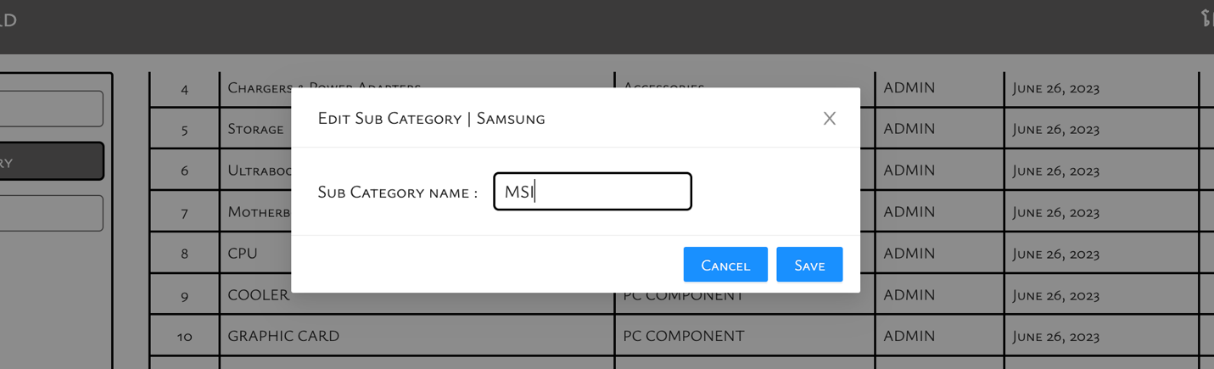

* + Product

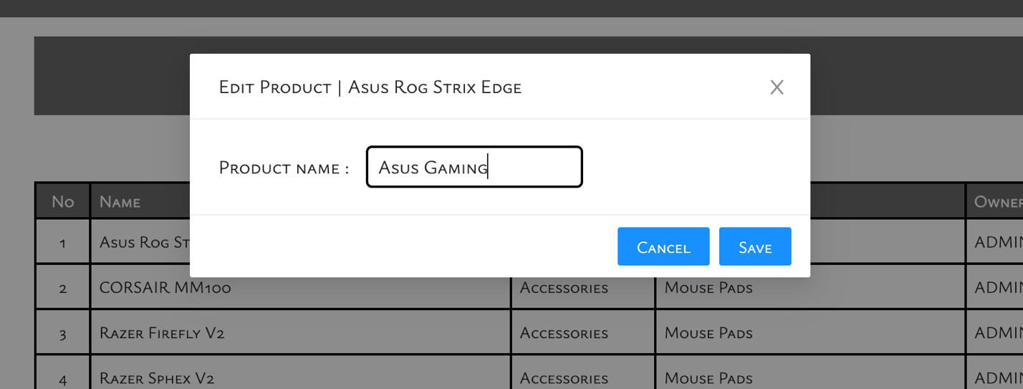

* Delete
  + Category

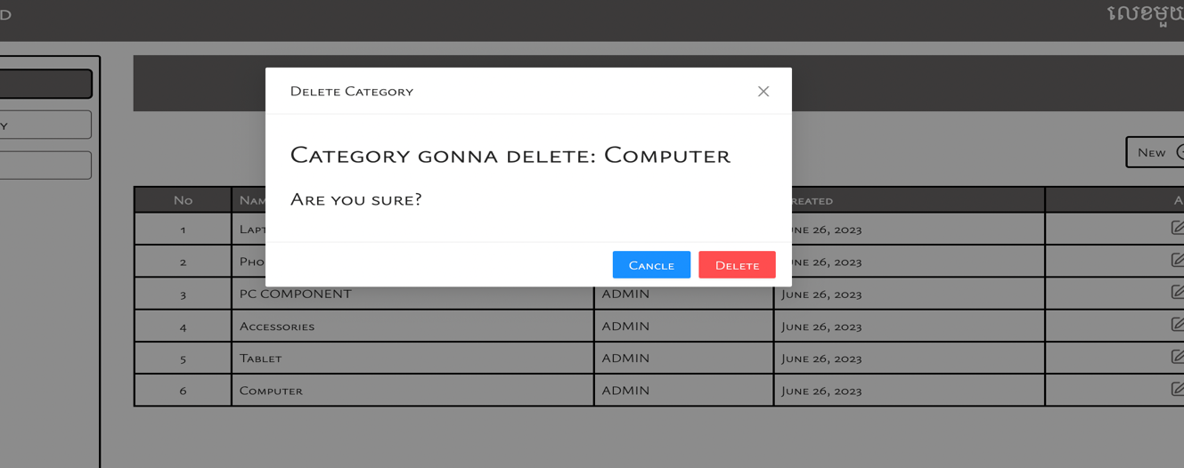

* + Sub-Category

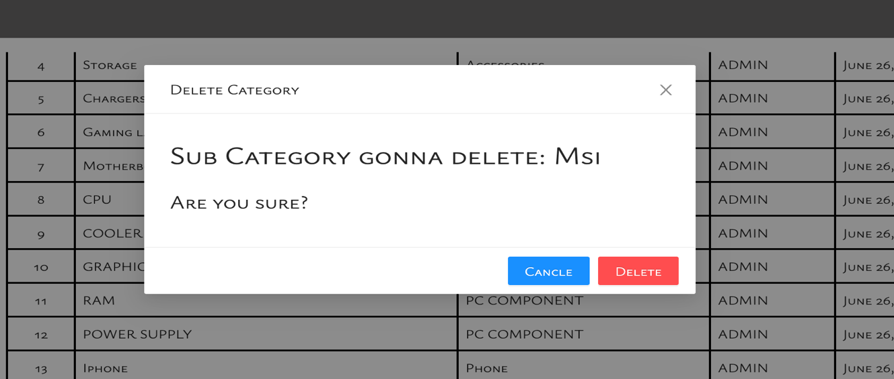

* + Product

